Project: Moffat Bay
Course: CSD 460
Description: Tests for the Landing Page
Date: 9/2/2026
To complete the test case plan, fill out the information for Project, Course, Description and Date in the header below.
.
TABLE OF CONTENTS
<DESCRIPTION> 2
<DESCRIPTION> 2
<DESCRIPTION> 3

For each test, the developer should: provide a test description, a test objective, the developer name and date tested. For each step, fill out the actions to be taken and describe the expected results, and indicate yes or no for each step depending upon the result. The peer tester should provide their name, date tested, indicate yes or no for each step depending upon the result, and a screenshot (thumbnail) of the result.

Test 1 | Landing Page Loads With Production Navigation and Script
 | Test Objective: Verify that the login page loads successfully and references only its production scripts, with no leftover references to the removed mock application files. | Developer: Brayan Covarrubias  Date tested: 2026/09/04 | Peer tester: Matthew Rozendaal  Date tested: 2026/09/05
Step | Action | Expected results: The login page returns HTTP 200, includes emailValidation.js, auth-chip.js, and login.js, and does not reference the removed mock-data.js, api-contract.js, or app.js files. | Developer pass/fail | Tester pass/fail  + Screenshot
1 | Start the Moffat Bay login-page server |  | Yes | Yes
2 | Navigate to http://127.0.0.1:8001/login.html |  | Yes | Yes
3 | Verify the landing page loads successfully |  | Yes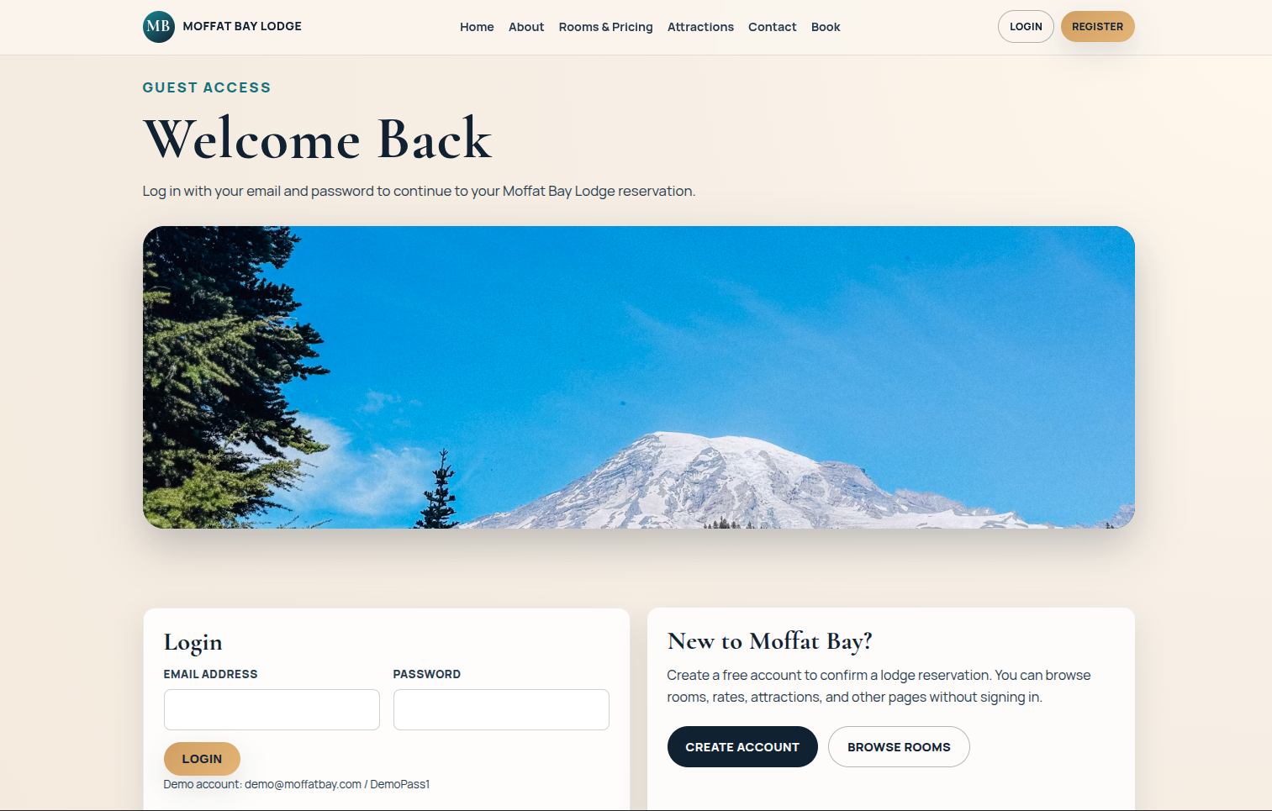 | Yes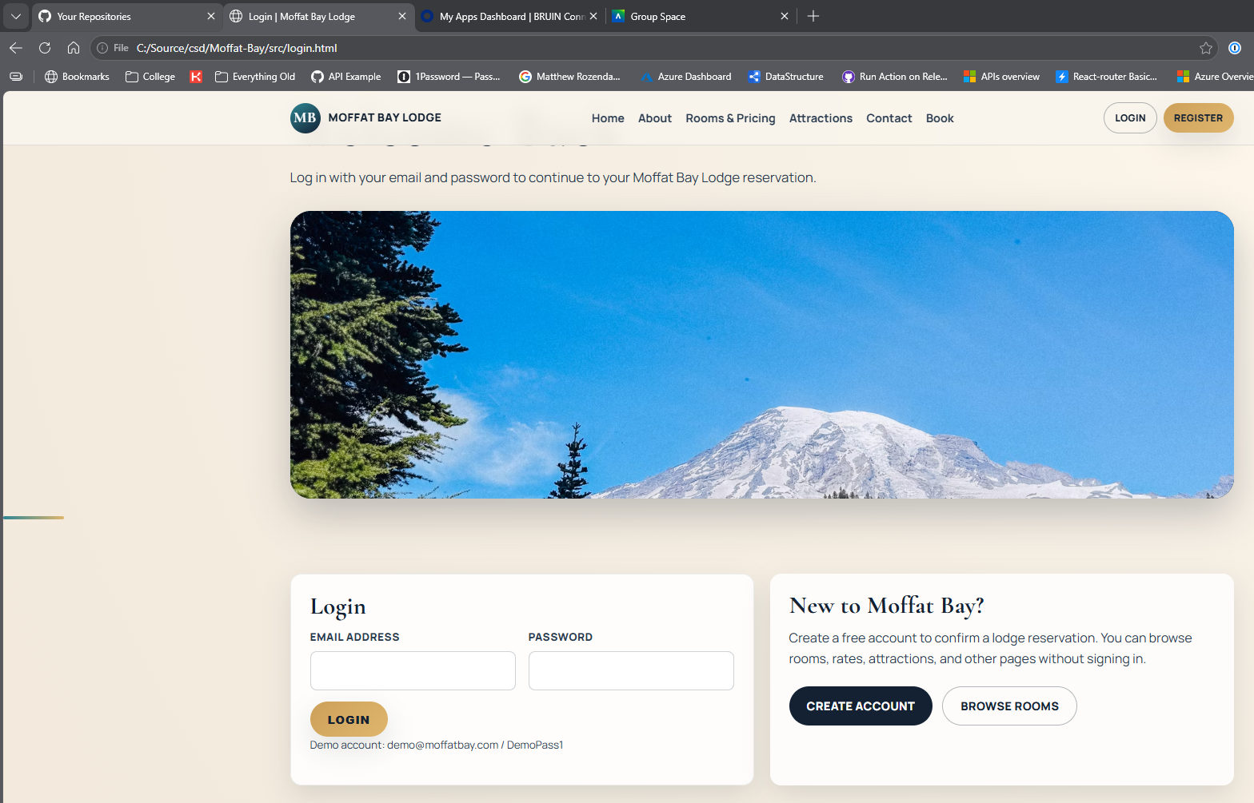
4 | Run FT-LOGIN-01 PyTest test |  | Yes | Yes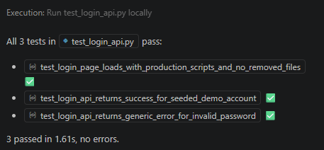
Comments | A later update after these tests were made allows for localhost viewing of the pages to be ablet o hit the python apis

Test 2 | Login API Accepts The Seeded Demo Account
 | Test Objective: Verify that the login API connects to the shared moffat_bay database and authenticates the seeded demo customer | Developer: Brayan Covarrubias  Date tested: 2026/09/04 | Peer tester: Matthew Rozendaal  Date tested: 2026/09/05
Step | Action | Expected results: | Developer pass/fail | Tester pass/fail
1 | Install mysql-connector-python and export MOFFAT_DB_PASSWORD |  | Yes | Yes
2 | Start the Moffat Bay login-page server |  | Yes | Yes
3 | - Navigate to http://127.0.0.1:8001/login.html |  | Yes | Yes
4 | - Verify the landing page loads successfully |  | Yes | Yes
5 | - Utilize the demo email and password credentials to log in |  | Yes | Yes
6 | - Verify a redirect to reservations.html |  | Yes | Yes
7 | - Verify the header updates the login area with the customer’s name | 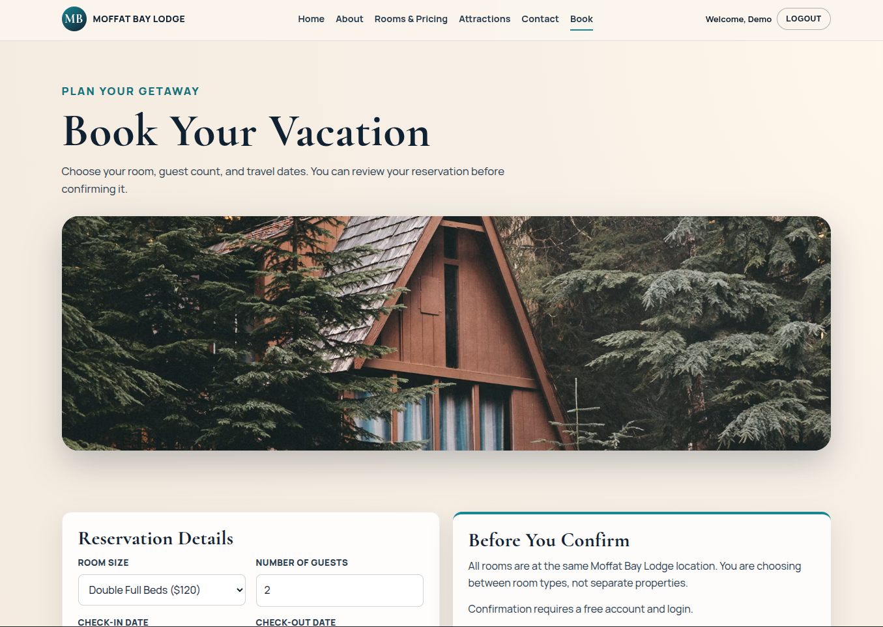 | Yes | Yes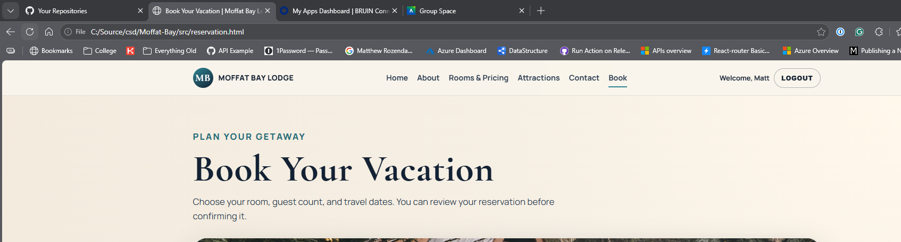
8 | - Run FT-LOGIN-02 PyTest test |  | Yes | Yes
Comments | A later update after these tests were made allows for localhost viewing of the pages to be ablet o hit the python apis

